**Lab 2: Data Carving**

**Group: CyberSec_N00b**

#### Member:

#### Huỳnh Ngọc Quang (SE181838)

#### Hồ Tài Liên Vy Kha (SE181818)

#### Hoàng Kim Long (DE180860)

#### Phạm Thành Long (SE181692)

#### Nguyễn Lê Hoàng Thông (SE182533)

1. **Extracting images from a corrupted Word document**

**Step 1.**

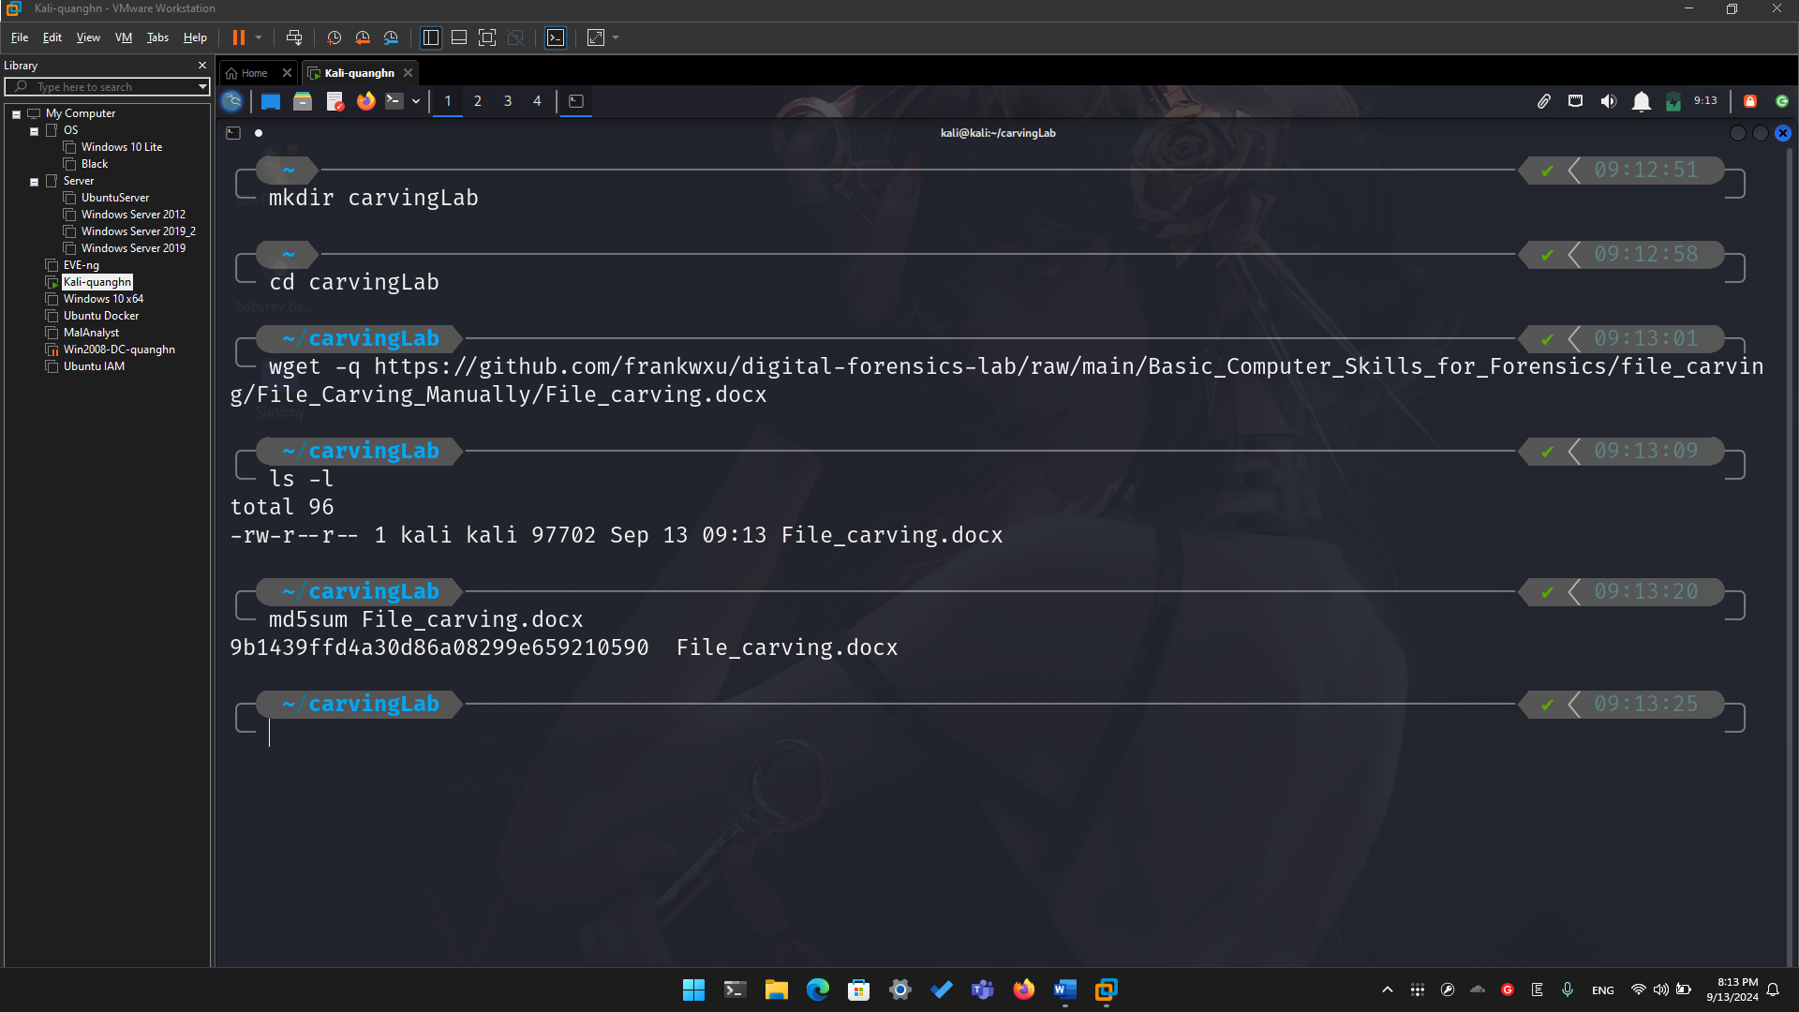

**Step 2.**

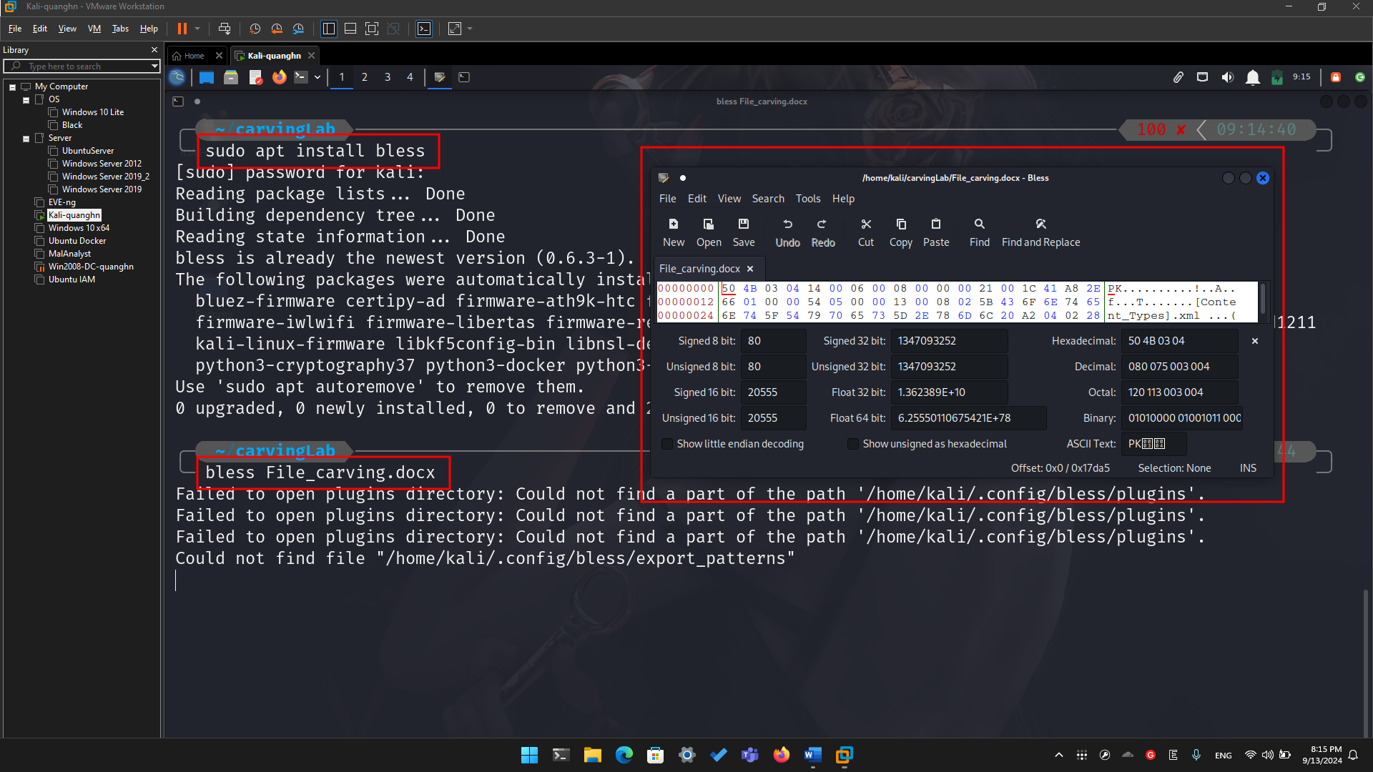

**Step 3.**

* Search file header start offset – 0F5E

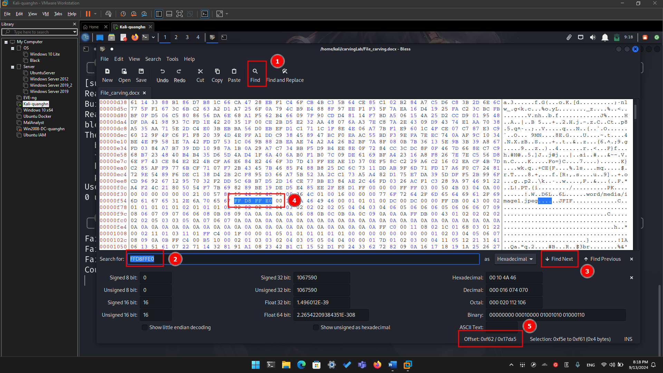

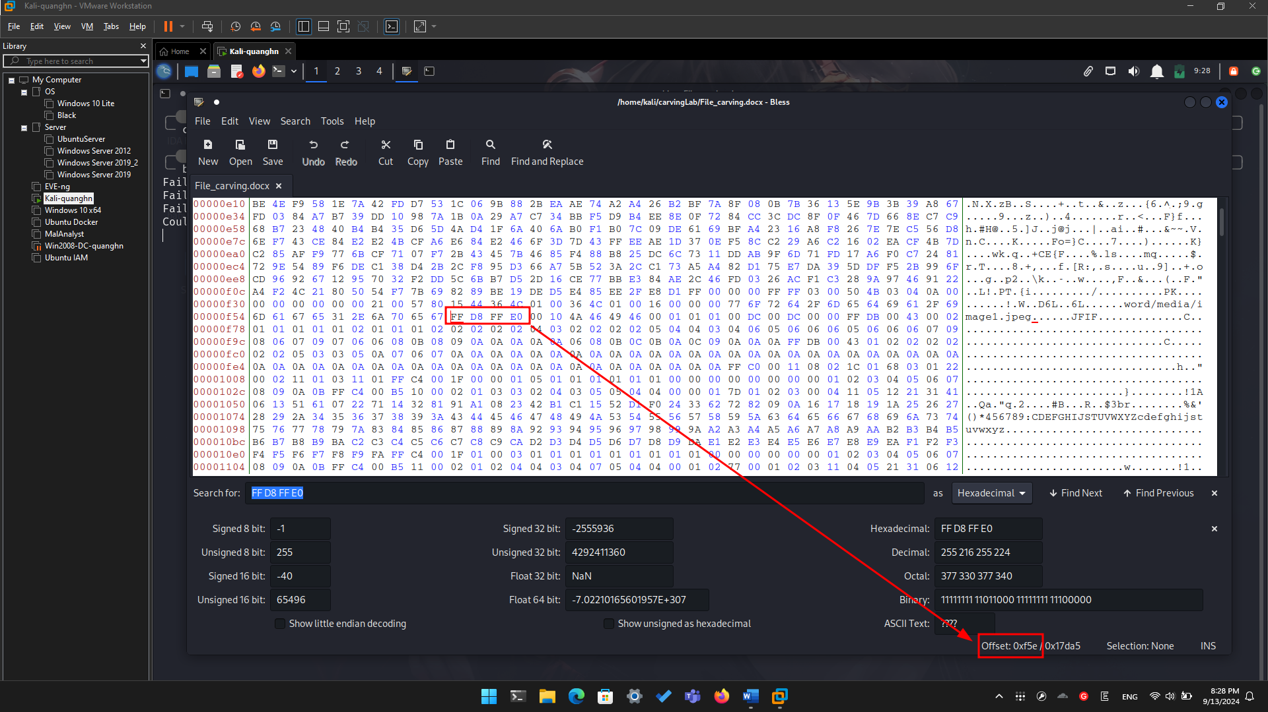

* Search file trailer ends offset – 15B93

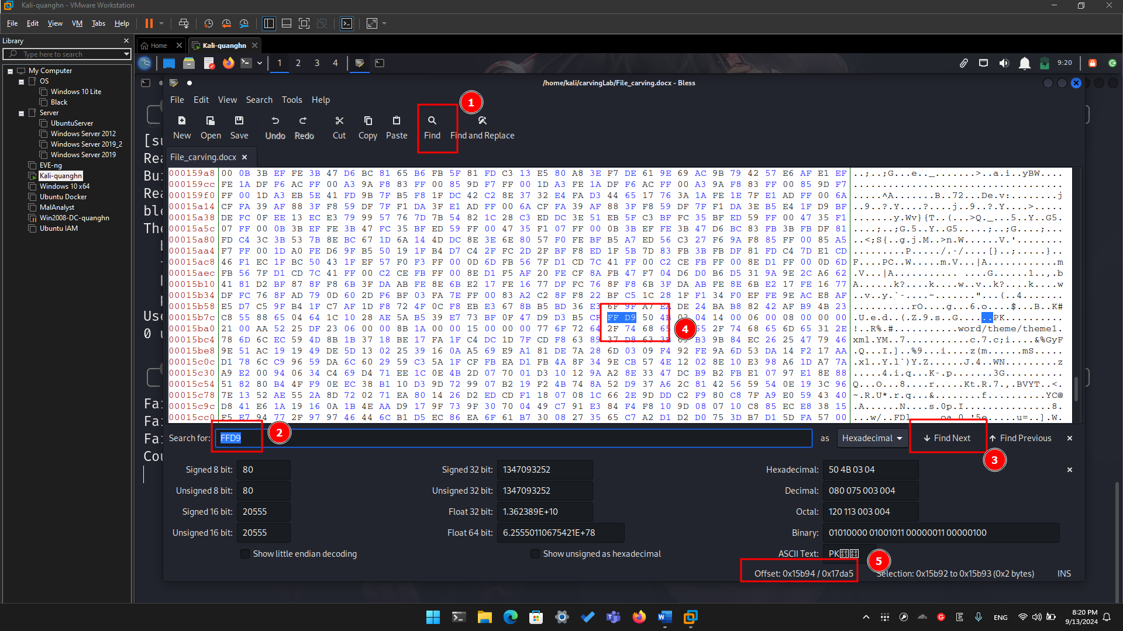

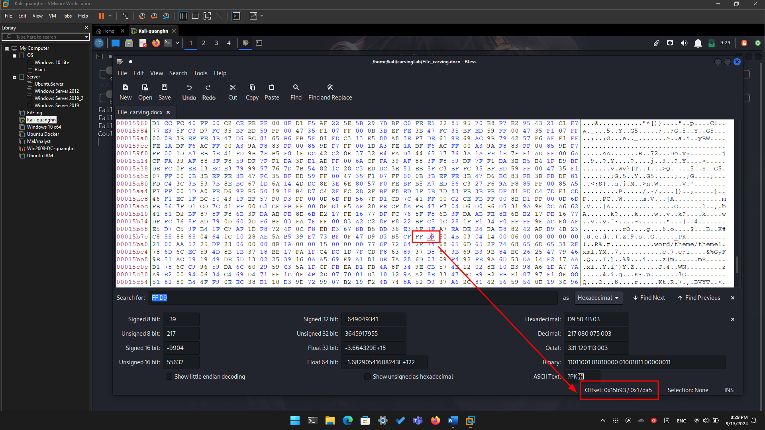

* Select hex from header to tail
* (0F5E)16=(3934)10
* (15B93)16=(88979)10

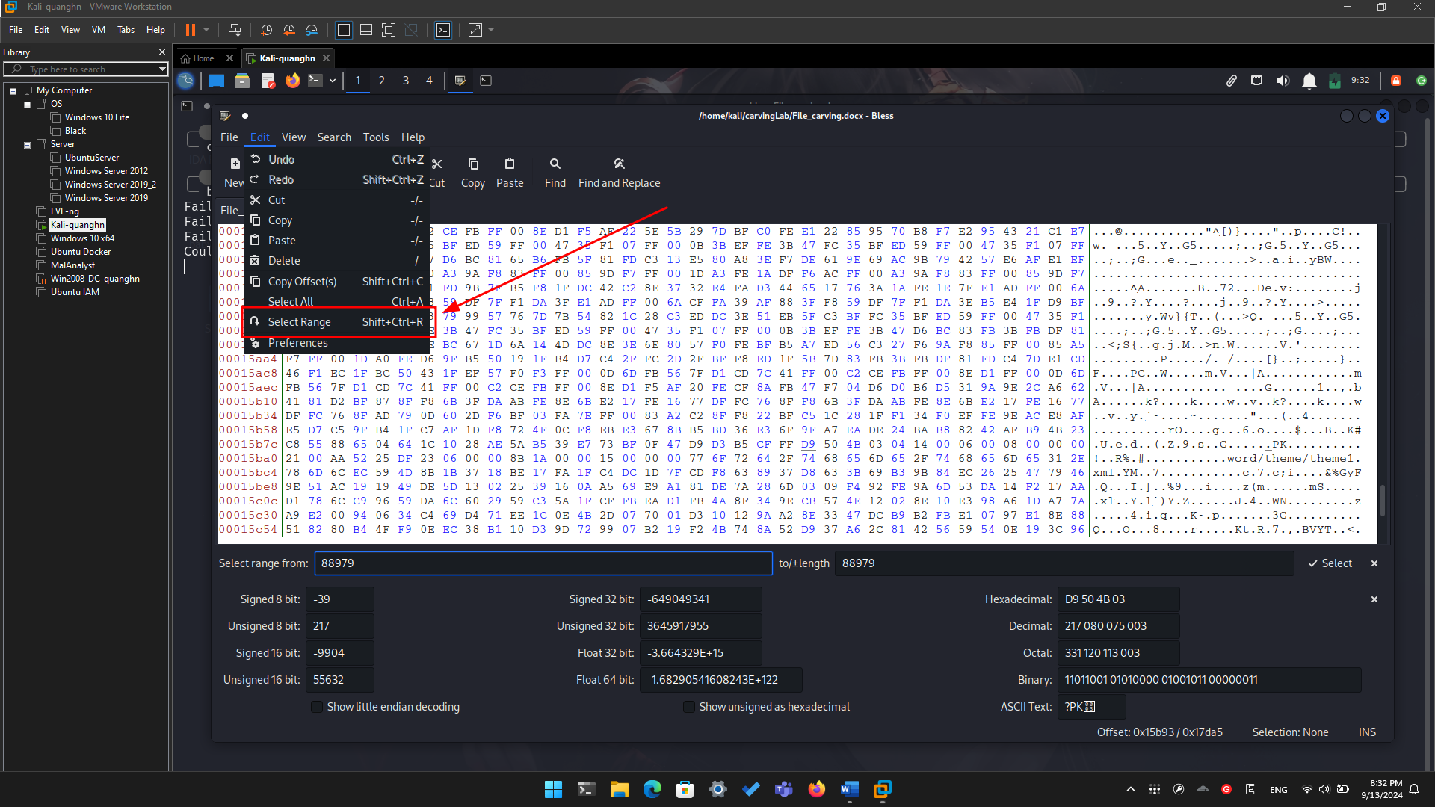

* Copy the selection

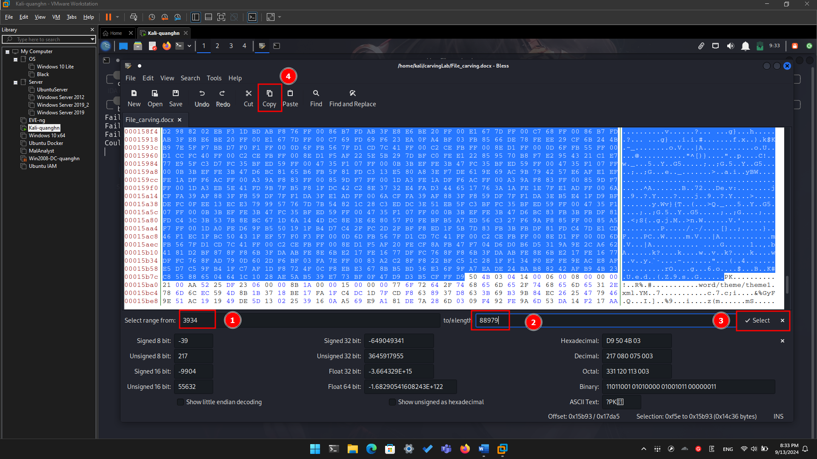

* Paste the selection

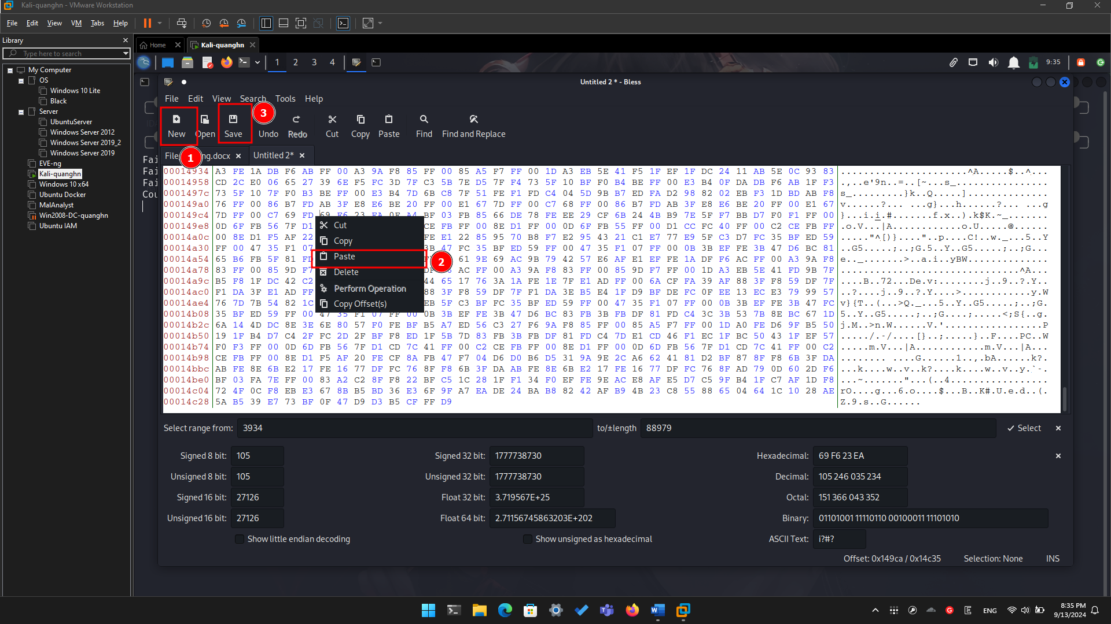

* Save the image

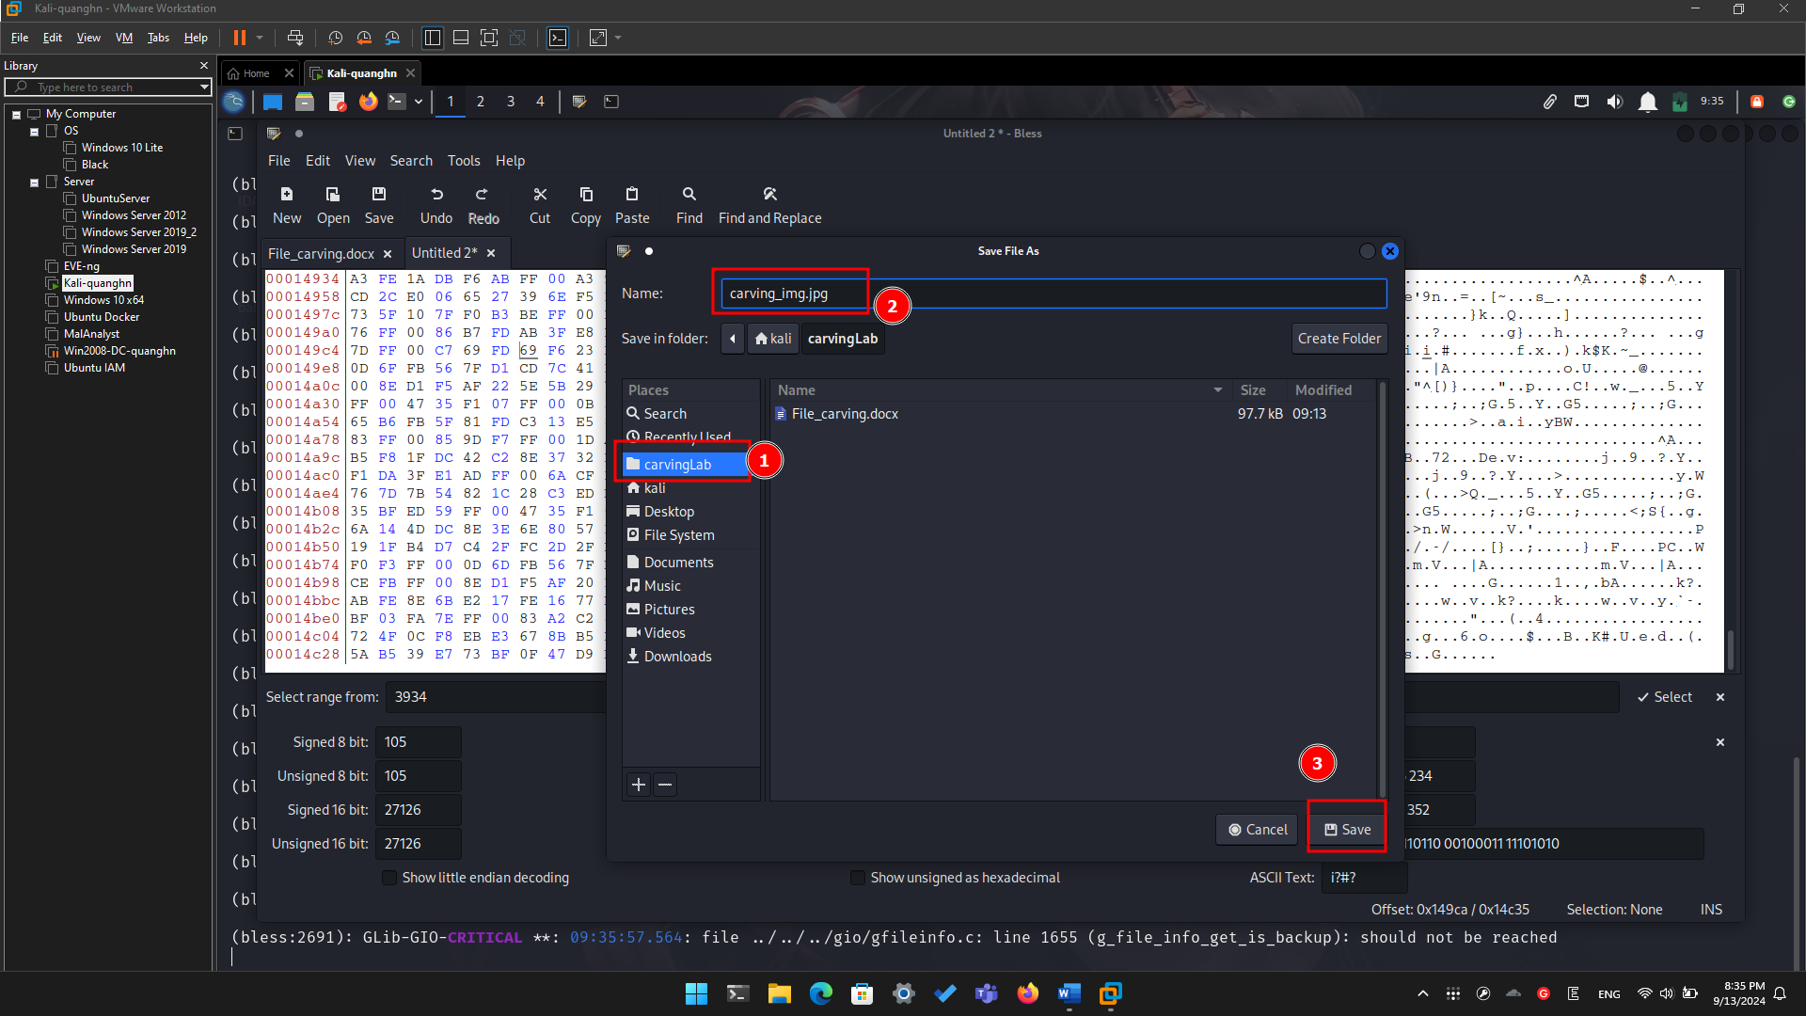

**Step 4.**

* Show the carved image

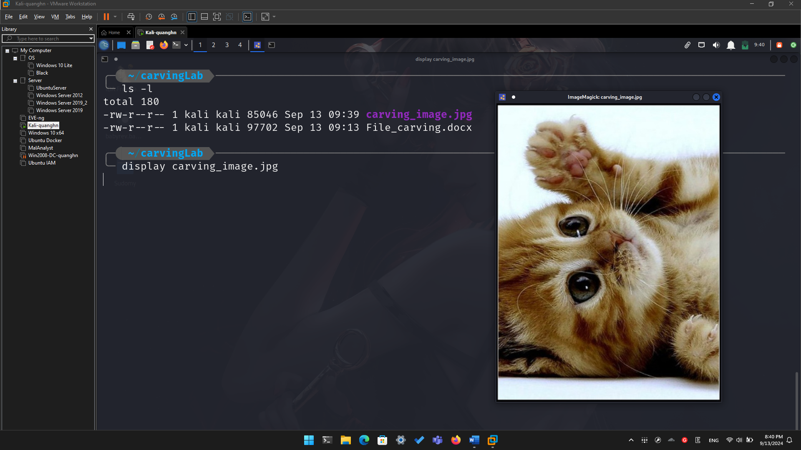

1. **Carving/Recovering a USB image**

* Prepare a USB image for file carving

**Step 1.**

* Download the zipped USB image

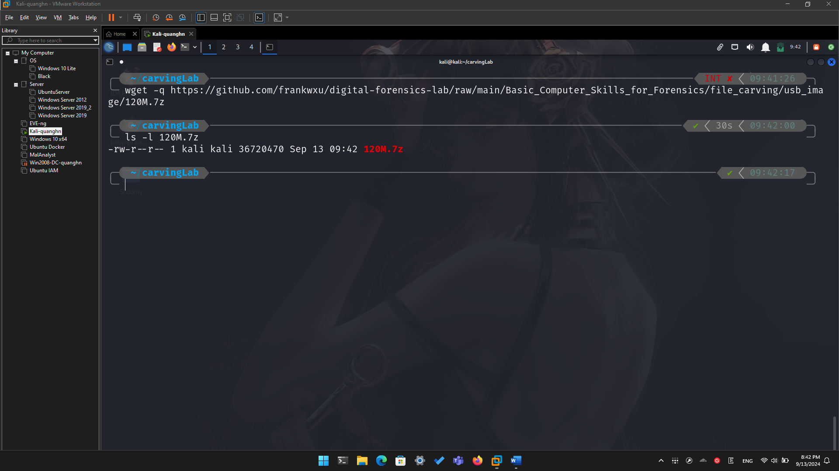

* Compute hashes

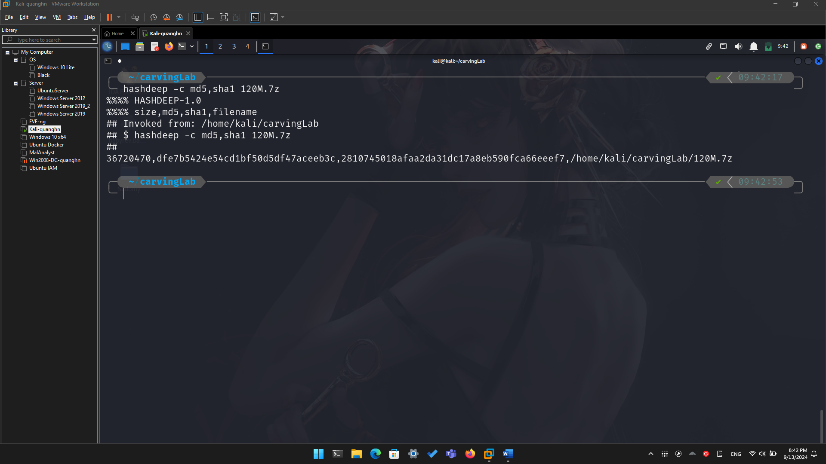

* List the content of the zipped file

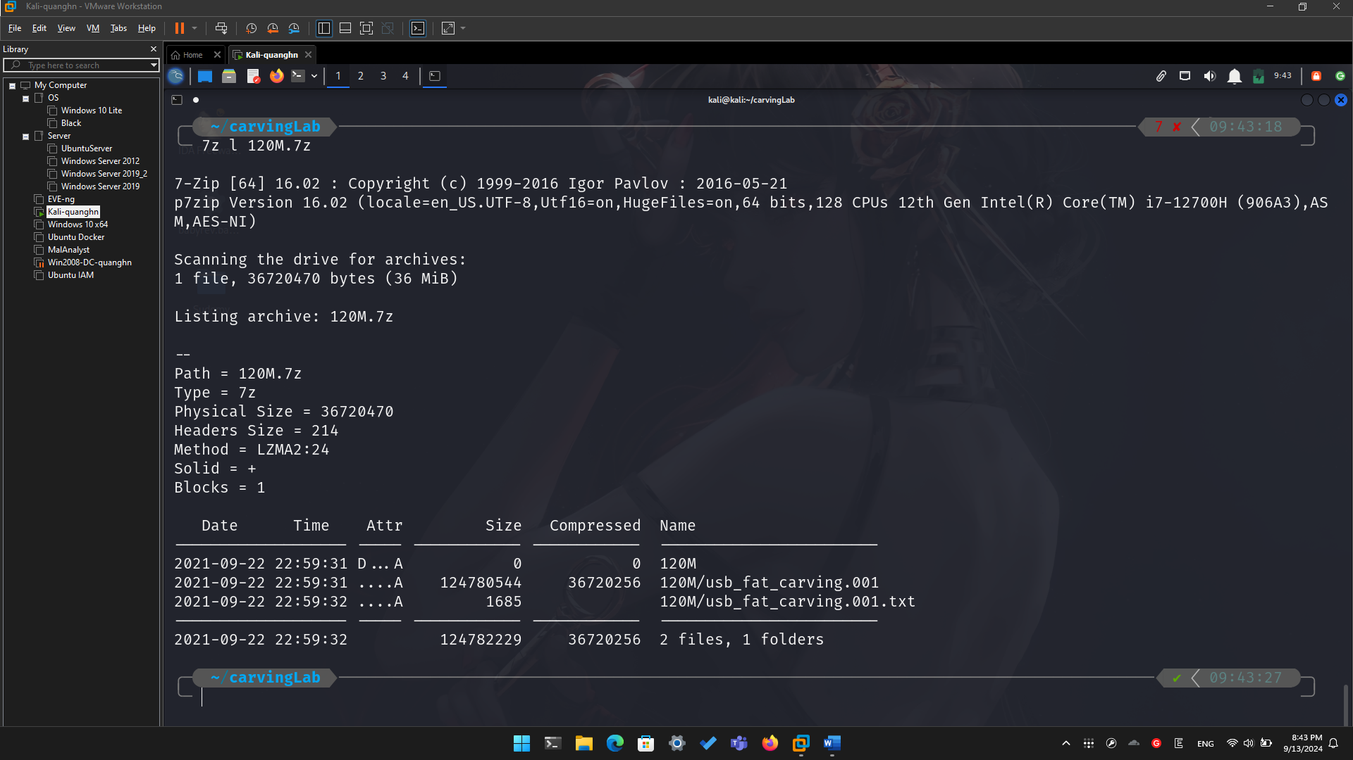

* Extract the content of the zipped file

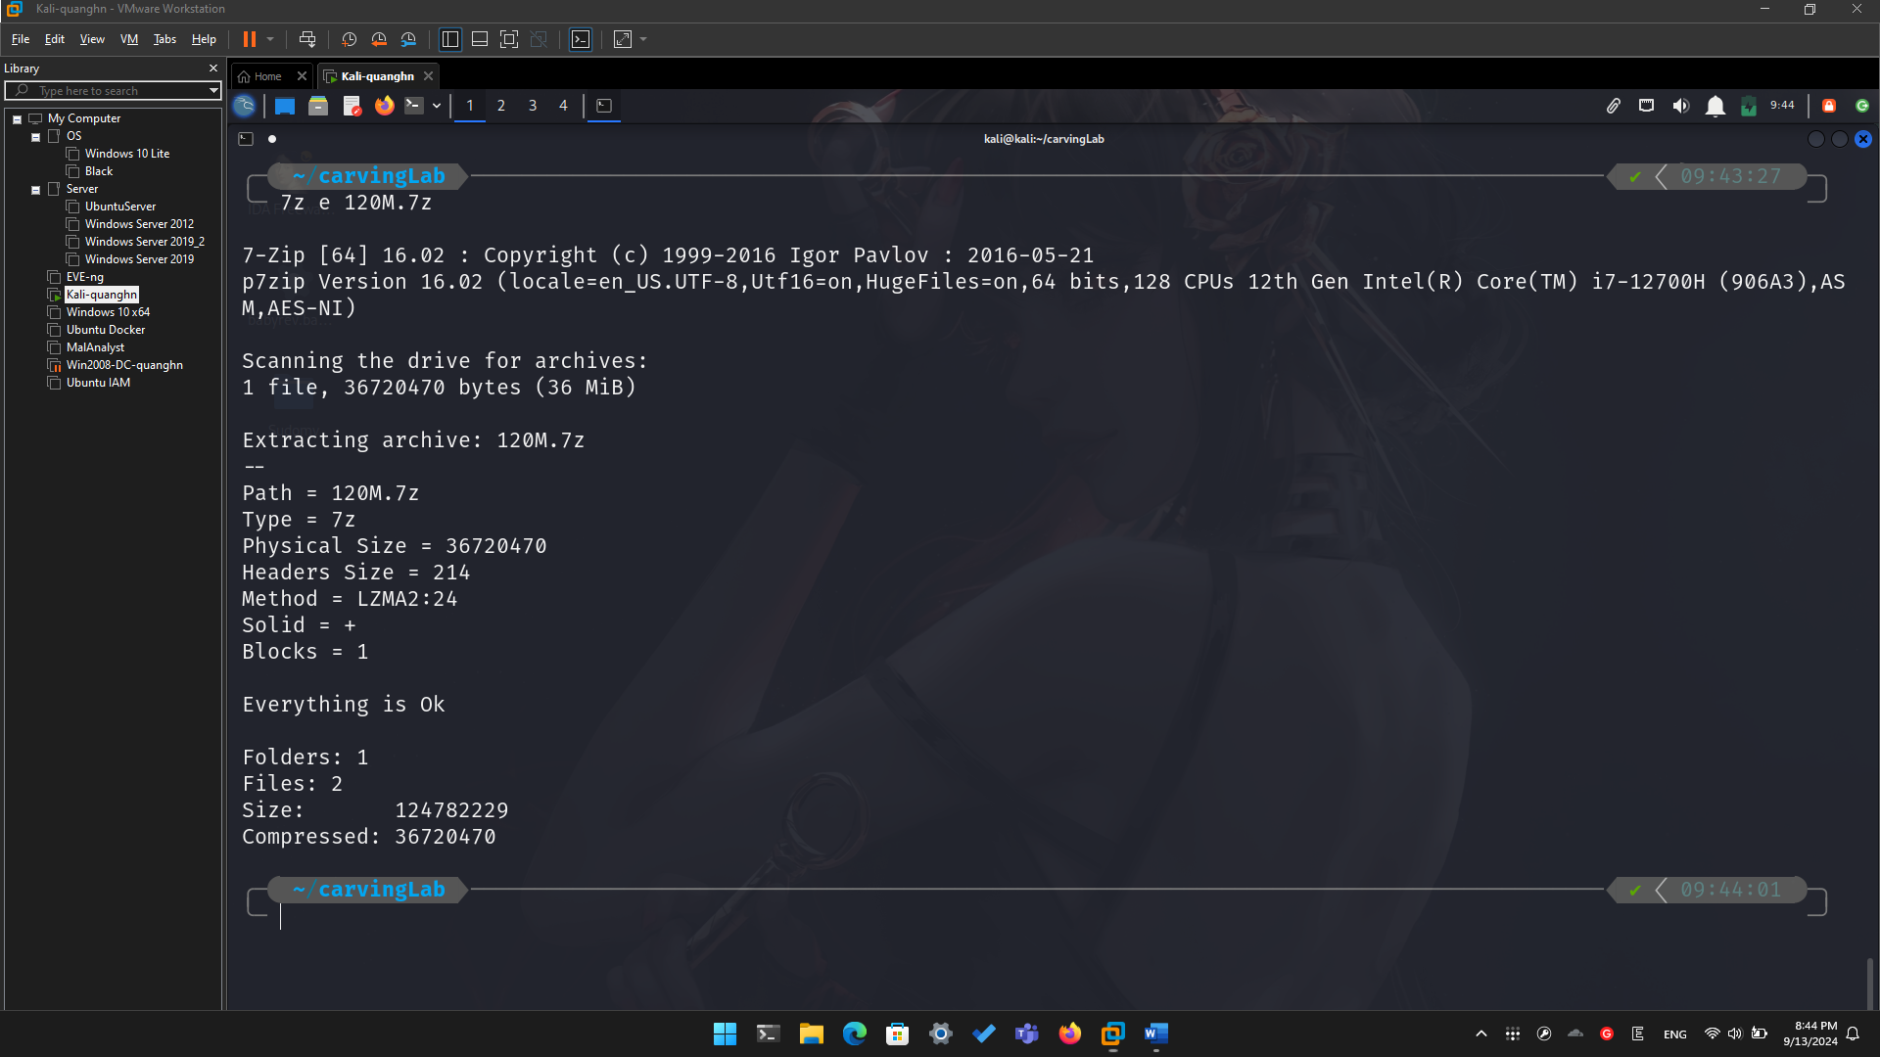

* Verify the hashes

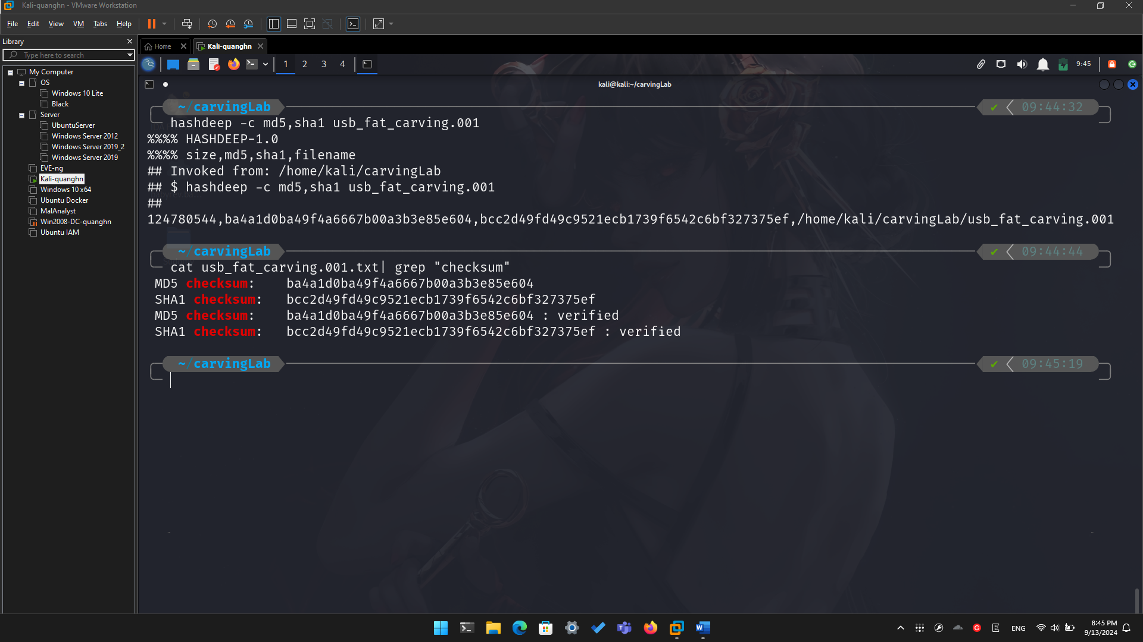

**Step 2.**

* Exam the content of the USB
* Display partitions

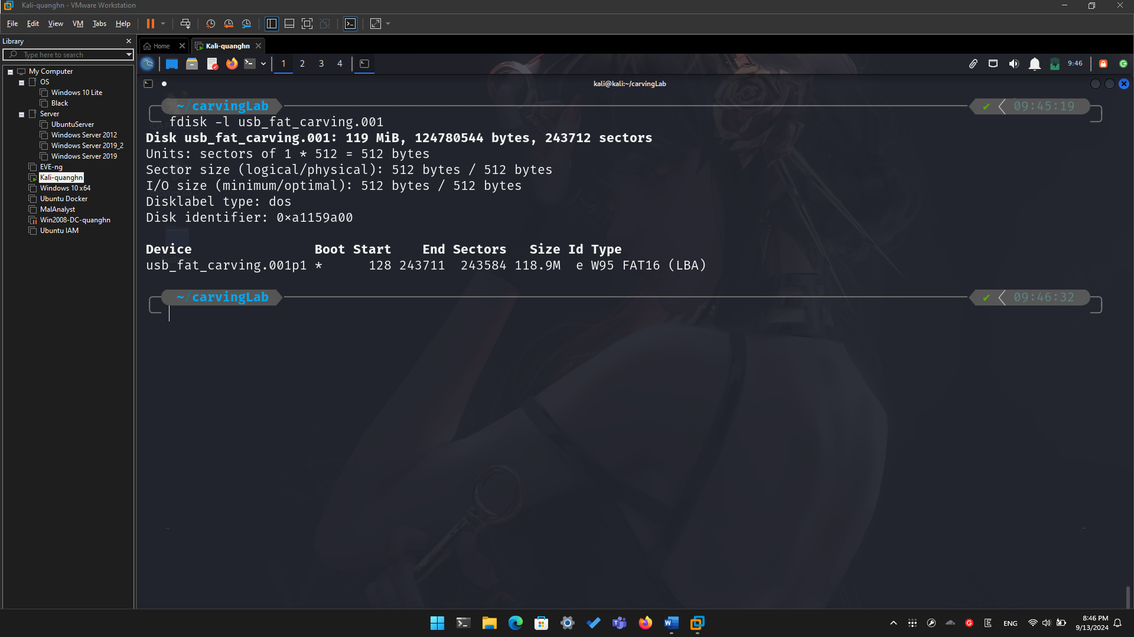

* Find deleted files

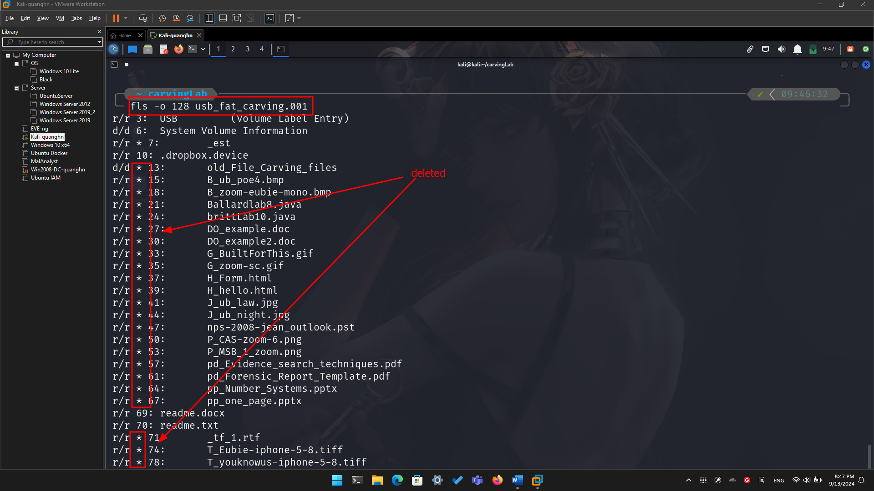

* Decide which file types need to carve

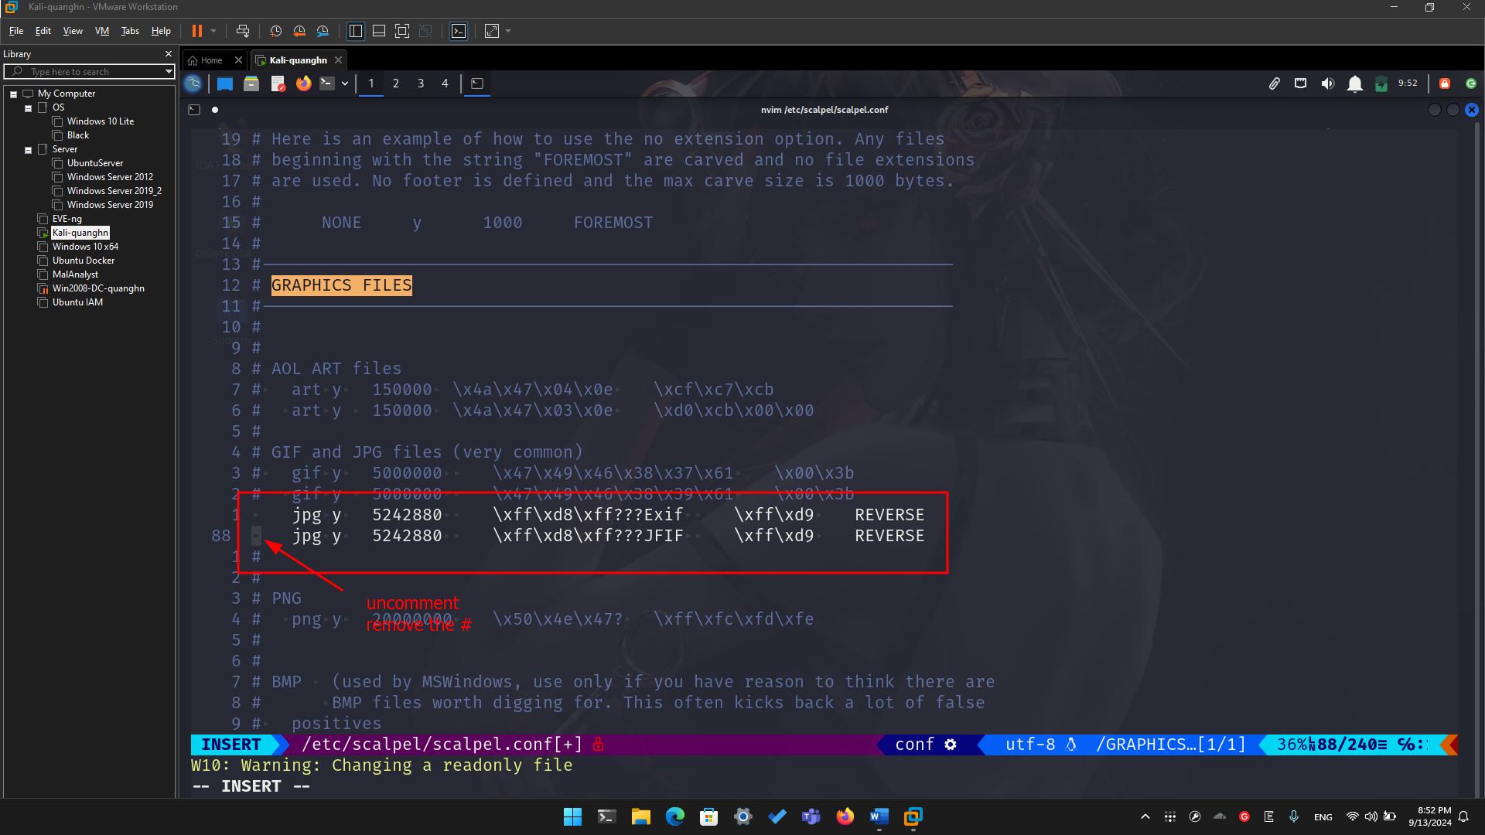

* Save it and quit!
* Show help

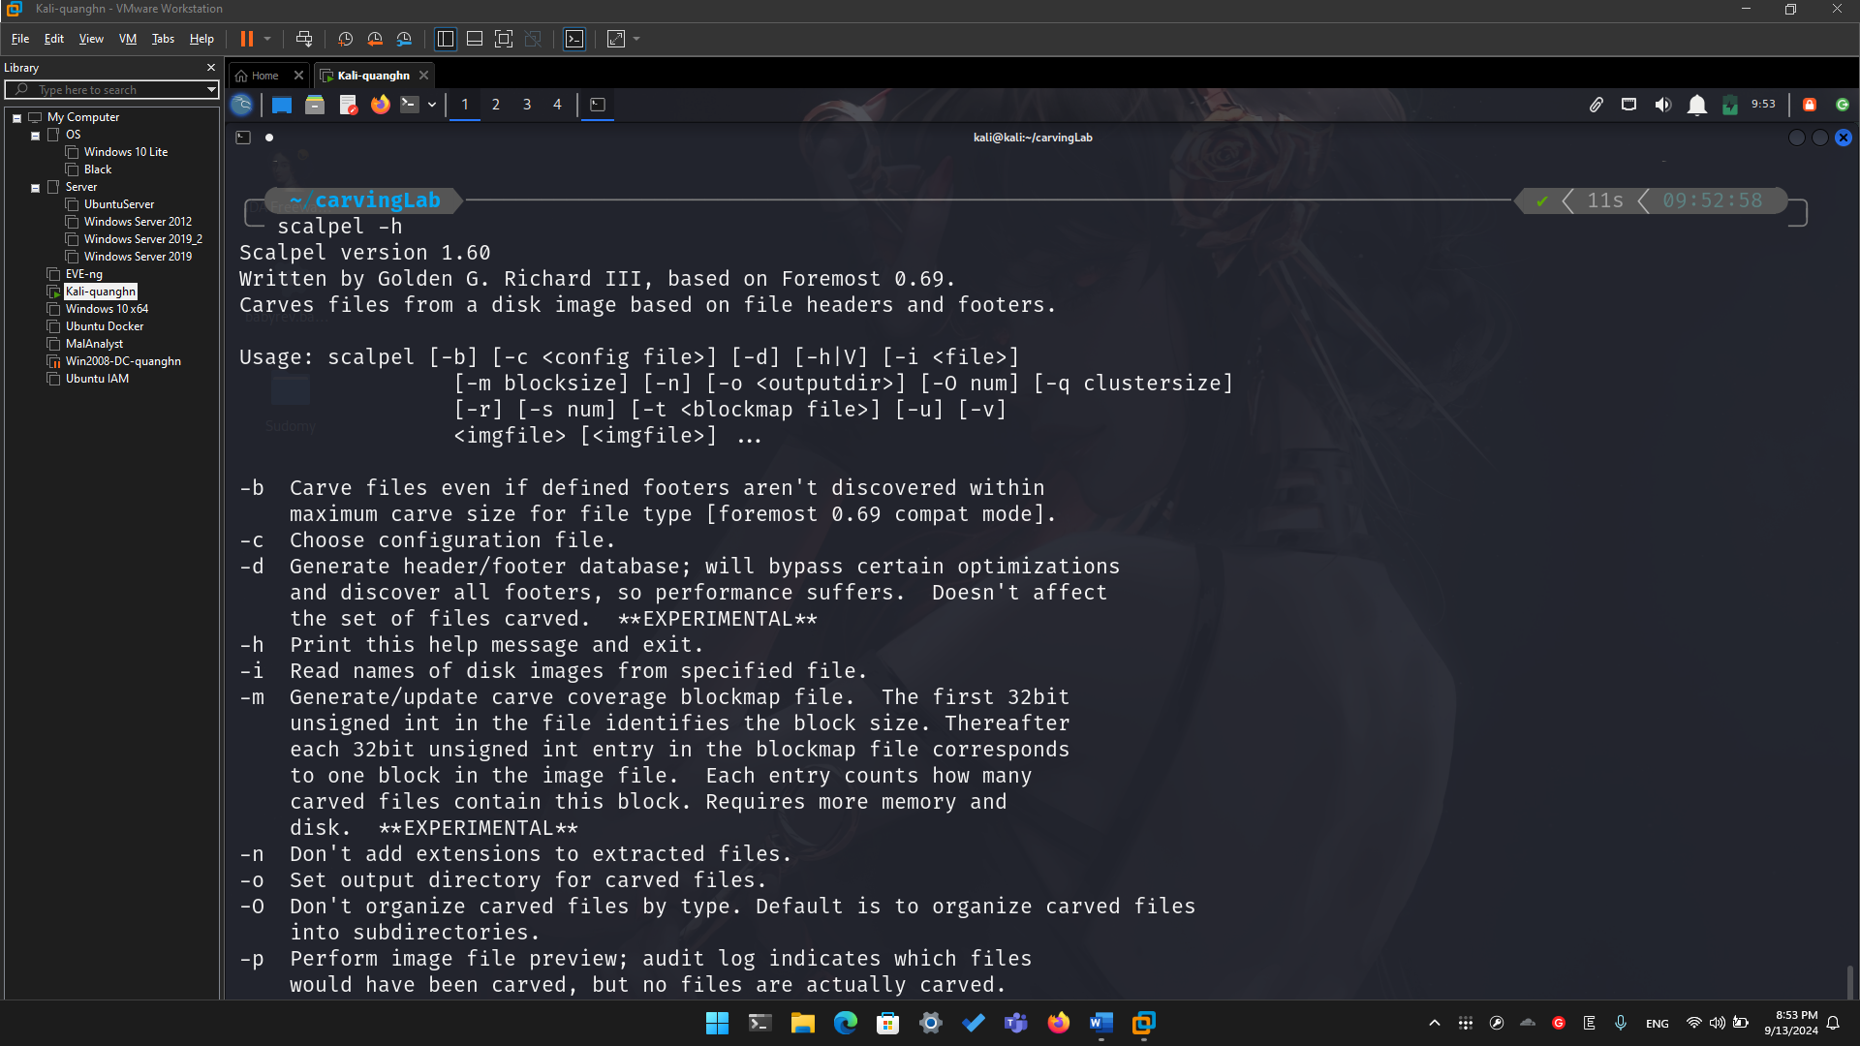

**Step 3.**

* Carving the USB image

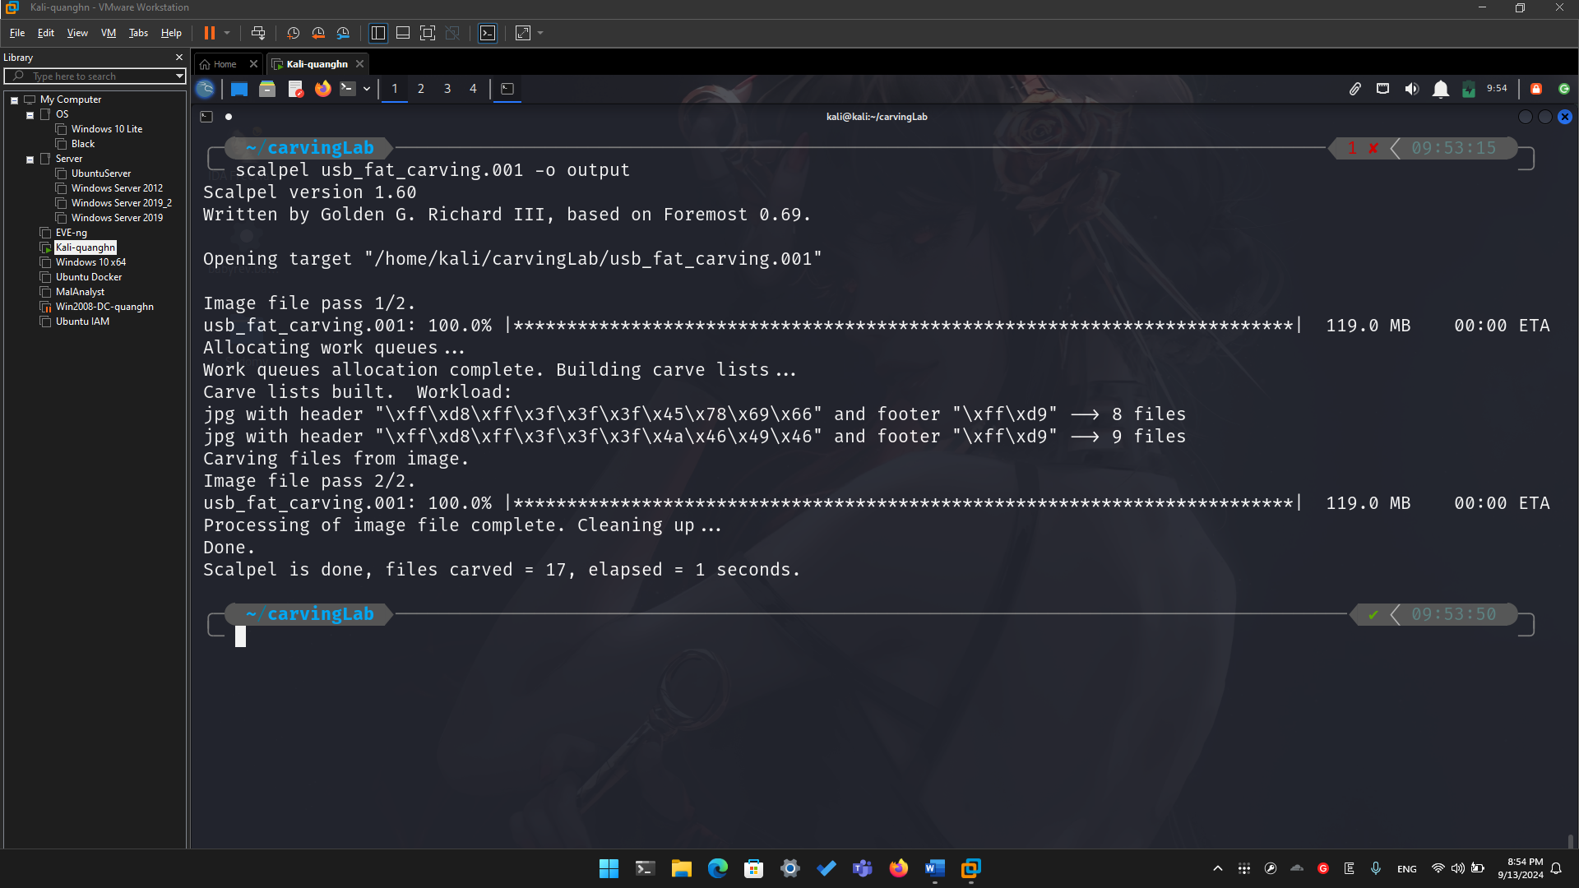

* Show carved files

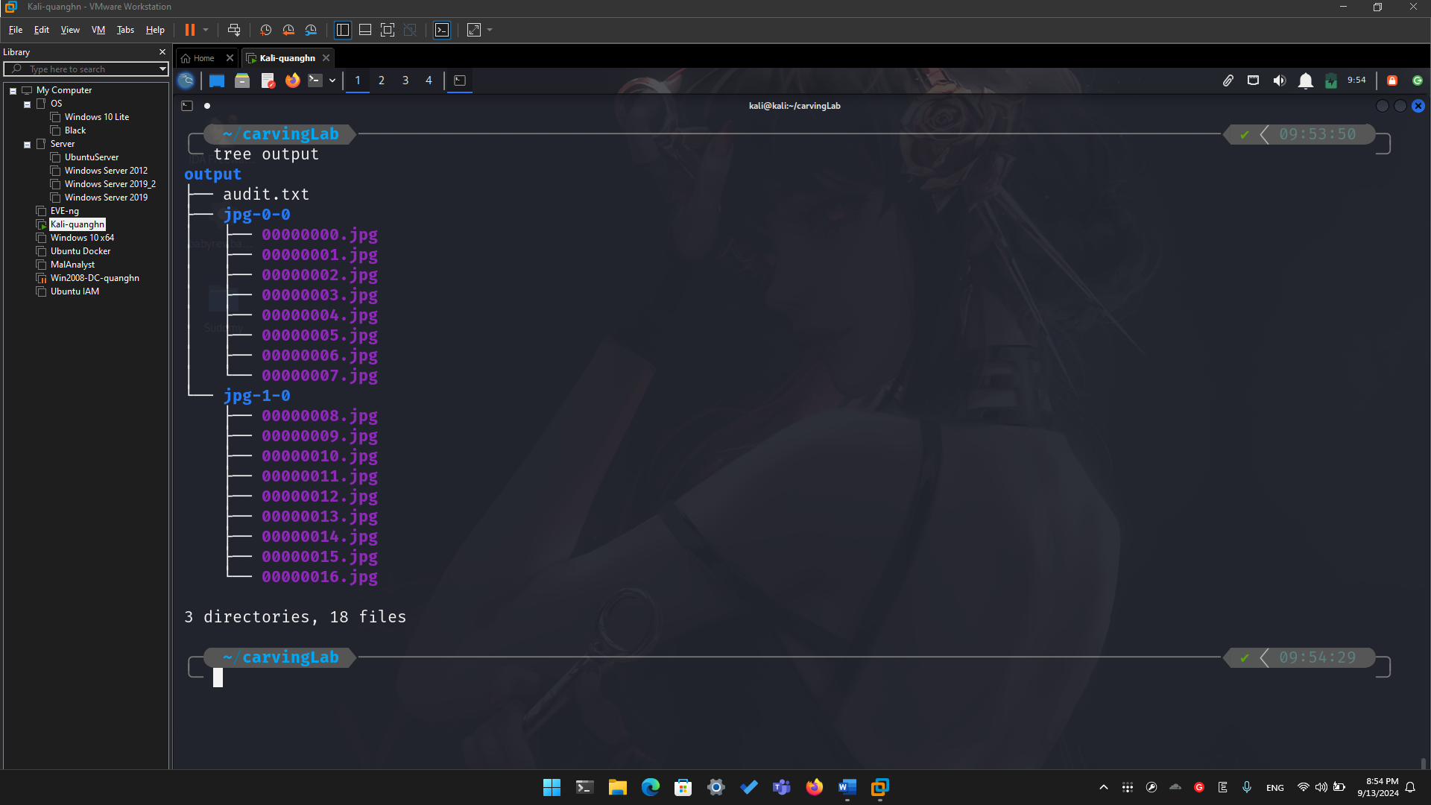

* Show audit log

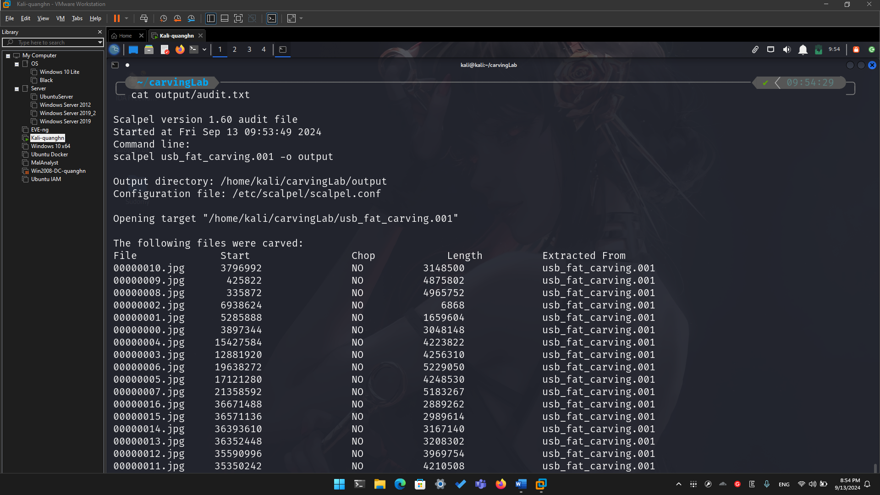

**Step 4.**

* Display two carved jpg image

